**Assignment # 02 – Applied Robotics**

**Student: Syed Saad Waqar (MTS-38-B)**

Question 1)

A) Translation vector = [ 2 3 0 ]’

B) Rotation Matrix: (CCW 90) [ 0 -1 0]

[ 1 0 0]

[ 0 0 1]

C) Transformation matrix: [ 0 -1 0 2 ]

[ 1 0 0 3 ]

[ 0 0 1 0 ]

[ 0 0 0 1 ]

------------------------------------------------------------------------------------------------------------

Question 2:

As rotation matrix in 2-d is given as:

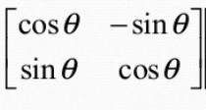

0T1 = 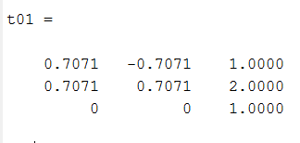

1T2  = 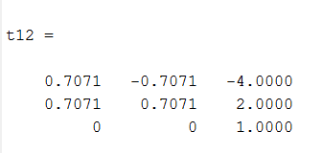

Now 0T2 = 0T1 x 1T2

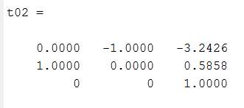

-------------------------------------------------------------------------------------------------------------------------------------------

Question 3 )

T = 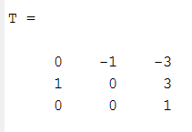

P = 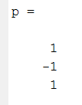

T_global = TxP = 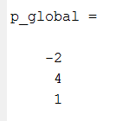

=====================================================================================

Question 4)

R = 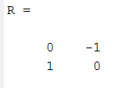

Vg = 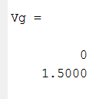

**Vl = R’ x Vg =**

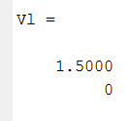

====================================================================================

Question 5) Python Code:

(Also present in the repository as codes.py)

import numpy as np  
import math  
  
def get_T_mat3d(rot,trans):  
 T = np.zeros((4,4))  
 T[0:3,0:3] = rot[:,:]  
 T[0:3,3] = trans[:,0]  
 T[3,:] = np.array([0,0,0,1])  
 return T  
  
def RotMat2d(degrees):  
 angle = (math.pi / 180)*degrees #converting into radians  
  
 rot = np.array([ [ math.cos(angle) , -math.sin(angle)],  
 [math.sin(angle) , math.cos(angle)]])  
 return rot  
  
def get_T_mat2d(rot,trans):  
 T = np.zeros((3, 3))  
 T[0:2, 0:2] = rot[:, :]  
 T[0:2, 2] = trans[:, 0]  
 T[2, :] = np.array([0, 0, 1])  
 return T  
  
  
#============= Question 1 ===================#  
  
rot = np.array([ [0, -1 ,0],  
 [ 1 ,0 ,0],  
 [0, 0 , 1]])  
trans = np.array([ [2],[3],[0]])  
print("Question 1 (C):\n",get_T_mat3d(rot,trans))  
print("==================\n")  
  
  
#============= Question 2 ====================#  
print("Question 2:")  
trans01 = np.array([ [1],  
 [2]])  
rot01 = RotMat2d(45)  
  
trans12 = np.array([ [-4],  
 [2]])  
rot12 = RotMat2d(45)  
  
T01 = get_T_mat2d(rot01,trans01)  
print("T01:\n",T01.round(2),"\n")  
  
T12 = get_T_mat2d(rot12,trans12)  
print("T12:\n",T12.round(2))  
  
T02 = T01@T12 #Matrix multiplication  
  
print("\n")  
print("T02:\n",T02.round(2))  
print("==================\n")  
#=============== Question 3 ===========================#  
print("Question 3:")  
  
T = np.array([ [ 0 , -1 , -3],  
 [1, 0 ,3],  
 [0, 0 ,1]])  
P = np.array([ [1],  
 [-1],  
 [1]])  
  
print("P_global:\n",T@P)  
  
print("==================\n")  
#=============== Question 4 ===========================#  
print("Question 4:")  
  
R = np.array([ [ 0, -1],  
 [1 , 0]])  
Vg = np.array([ [ 0],  
 [1.5]])  
  
print("V_local = R'x Vg :\n",R.transpose()@Vg )  
print("==================\n")